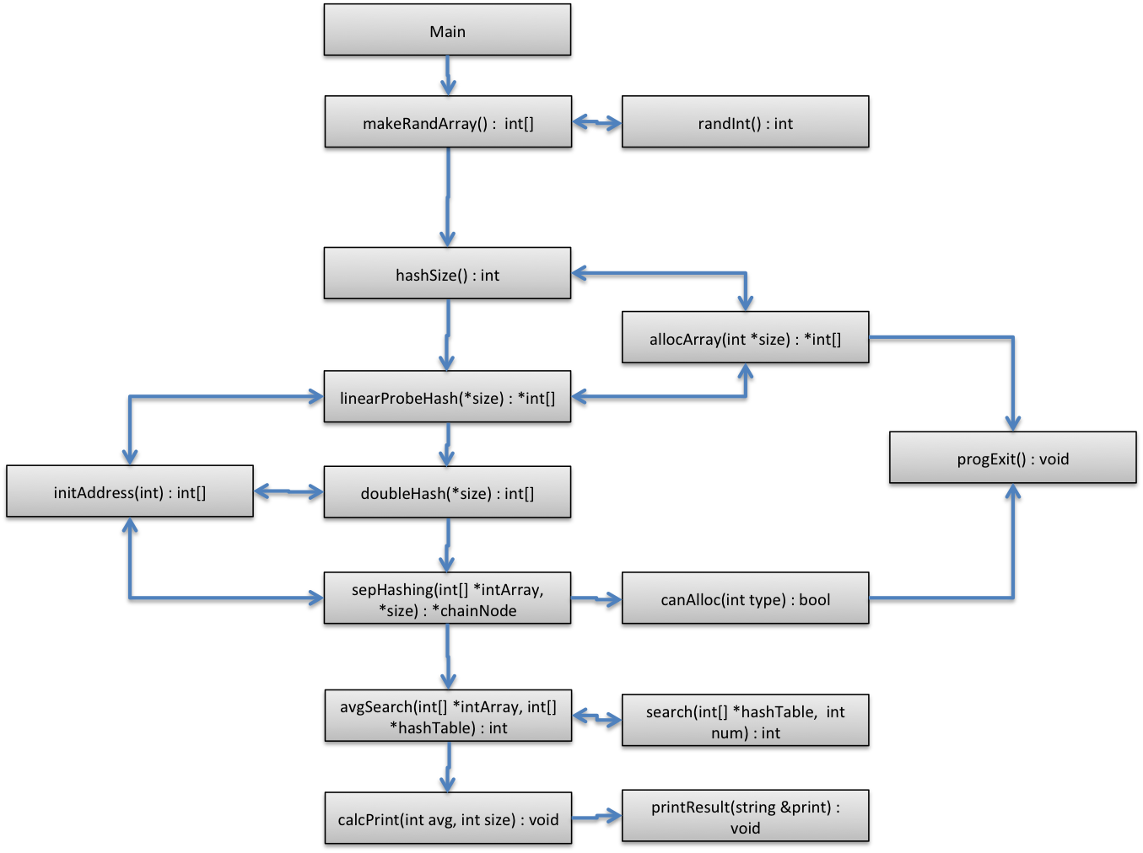

Functions and Responsibility:

makeRandArray – Tatsumoto

randInt – Tatsumoto

hashSize – Tatsumoto

allocArray – Tatsumoto

linearProbeHash – Valero

doubleHash – Valero

initAddress - Valero

progExit – Tatsumoto

canAlloc – Valero

sepHashing – Valero

avgSearch – Tatsumoto

search – Tatsumoto

calcPrint – Valero

printResult - Valero